Journey Through The Bible

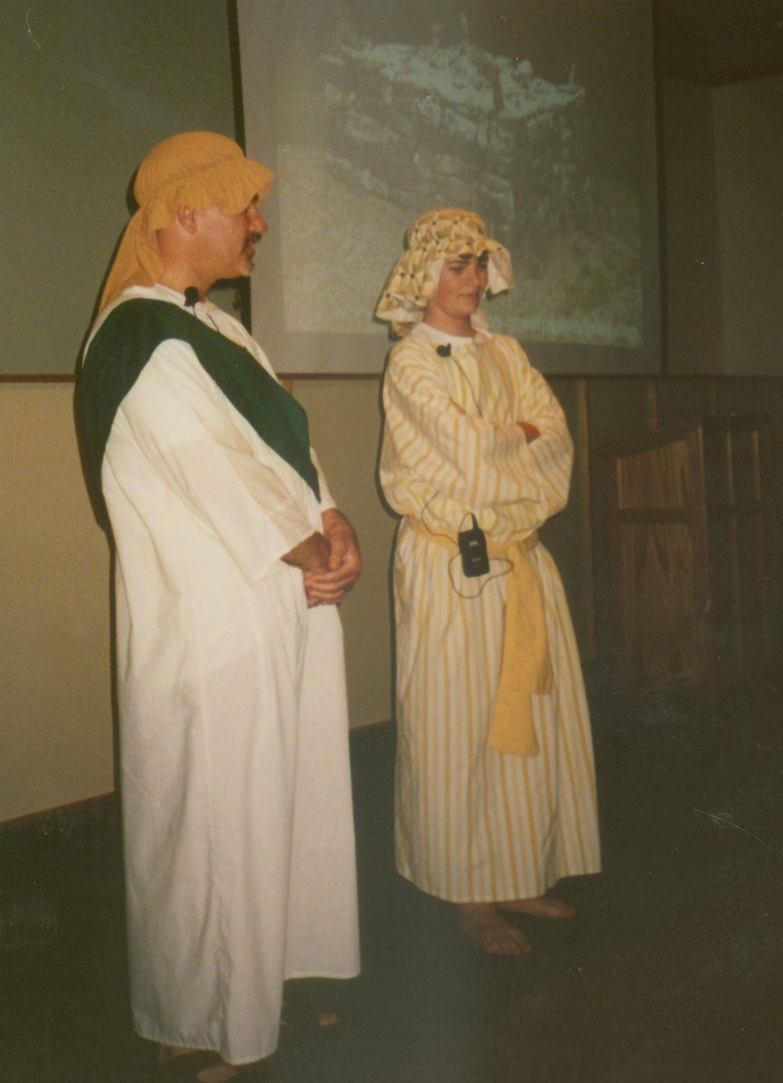

**ABRAHAM AND ISAAC**

Genesis 22:1-19

My name is Abraham. God made a covenant (promise) with me saying that I would become the father of many nations.

He then changed my name from Abram to Abraham and my wife's name from Sarai to Sarah. We were told that Sarah and

I would become parents of a son. I was so amazed that I laughed, because, at that time, I was ninety-nine and Sarah was 89. But when I was one hundred years old and his mother, Sarah, was ninety Isaac was born. God told us to name him Isaac which means, "he laughs". Isaac grew and became a fine son.

One day God said, "Abraham, take your son, your only son Isaac, whom you love, and go to the land of Moriah and offer him there as a burnt offering on one of the mountains that I shall show you." I rose early in the morning, saddled my donkey, and took two of my young men servants with me, and my son Isaac. I cut the wood for the burnt offering, set out and went to the place in the distance that God had shown me. After three days, I saw the place far away, so I said to my young men, "Stay here with the donkey; the boy and I will go over there; we will worship, and then we will come back to you."

I took the wood of the burnt offering and laid it on my son Isaac, and I took the fire and the knife. We walked on together.

Then Isaac said "Father the fire and the wood are here, but where is the lamb for a burnt offering?" My father Abraham said, "God Himself will provide the lamb for a burnt offering, my son." We continued to walk on together.

When we came to the place that God had shown my father he built an altar there and laid the wood in order. He then tied me up and laid me on the altar, on top of the wood. It was then that I realized that I was to be the sacrifice. I was frightened when my father, Abraham, reached out his hand and took the knife to kill me.

Then a wonderful thing happened! The angel of the lord called to Father Abraham from heaven and said, "Abraham, Abraham!" My father answered and said, "Here I am." The angel said, "Do not lay your hand on the boy or do anything to him, for now I know that you fear God, since you have not withheld your son, your only son, from Me."

My father, Abraham, looked up and saw a ram, caught in a thicket (a thorny bush) by its horns. Father went and took the ram and offered it up as a burnt offering instead of me.

My father called that place, "The Lord will provide," because it is said to this day, "On the mount of the Lord, it shall be provided."

My father and I are so thankful to our Heavenly Father for His goodness and mercy. We plan to serve Him faithfully all the days of our lives.

**Memory Verse:**

☼ Ask, and it will be given to you; seek, and you will find.

**What did you learn from this lesson?**

☺ God provides for those who obey.

**Do you know? Answer on back page**



**?** **Who provided for Abraham’s sacrifice?**

**Bible*W*ay Publishing grants permission to reproduce for non-commercial purposes lessons in their entirety without change or charge.**

**Randolph Dunn, Publisher - Roberto Santiago Editor**

**Contact us at Questions@ thebiblewayonline.com**

Websit[e **thebiblewayonline.com**](http://www.thebiblewayonline.com/)

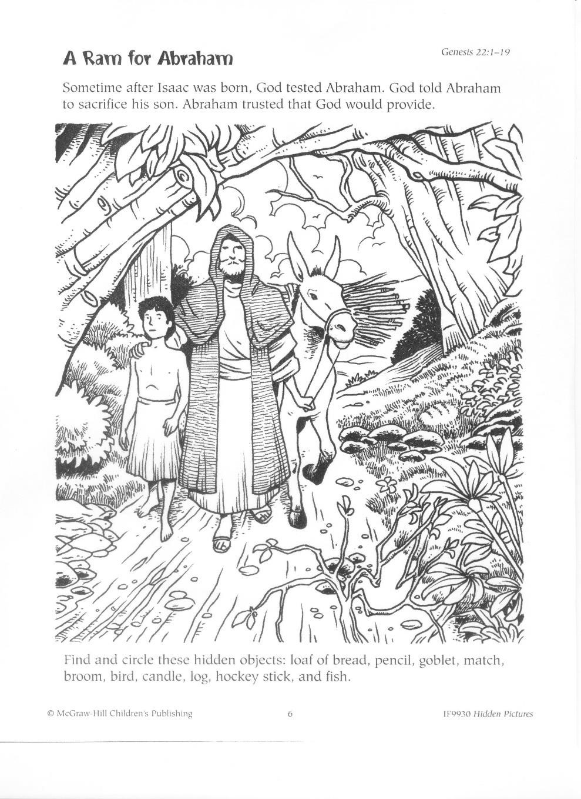

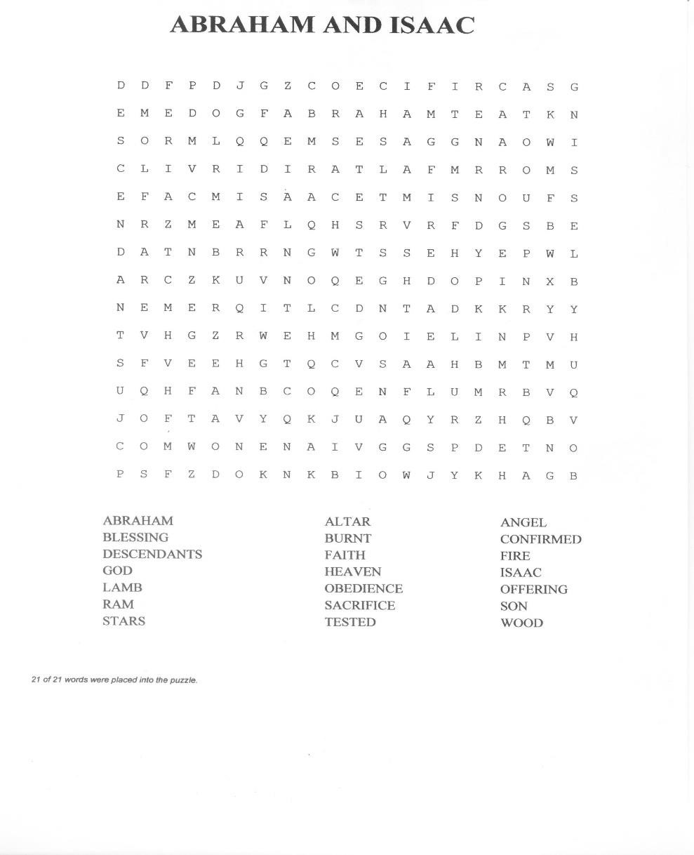

**? Answer to do you know.**

**● God provided the ram**